# Database System 2020

**HOMEWORK #9 Chap 6** ☺

This homework is Due on 12/23/2020

1. (10 points) Basic Definitions:

# 甲、Base relation 關係及其元組實際上是由DBMS創建並儲存為文件的

乙、**Virtual relation**

通過CREATE VIEW語句創建。不對應任何實際上的文件。

1. (10 points) Create a database for your assigned project.

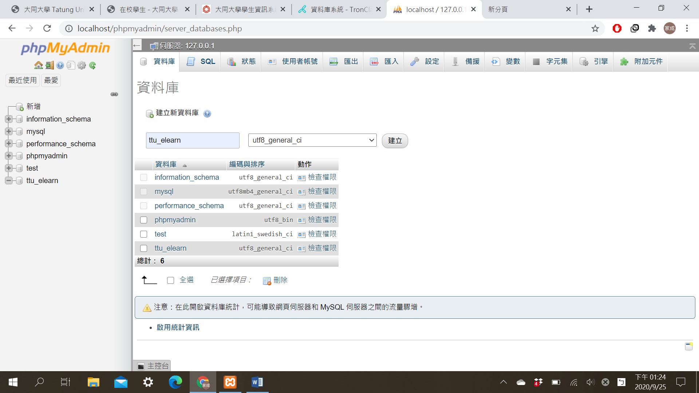

1. (10 points) Create database schema or your assigned project.

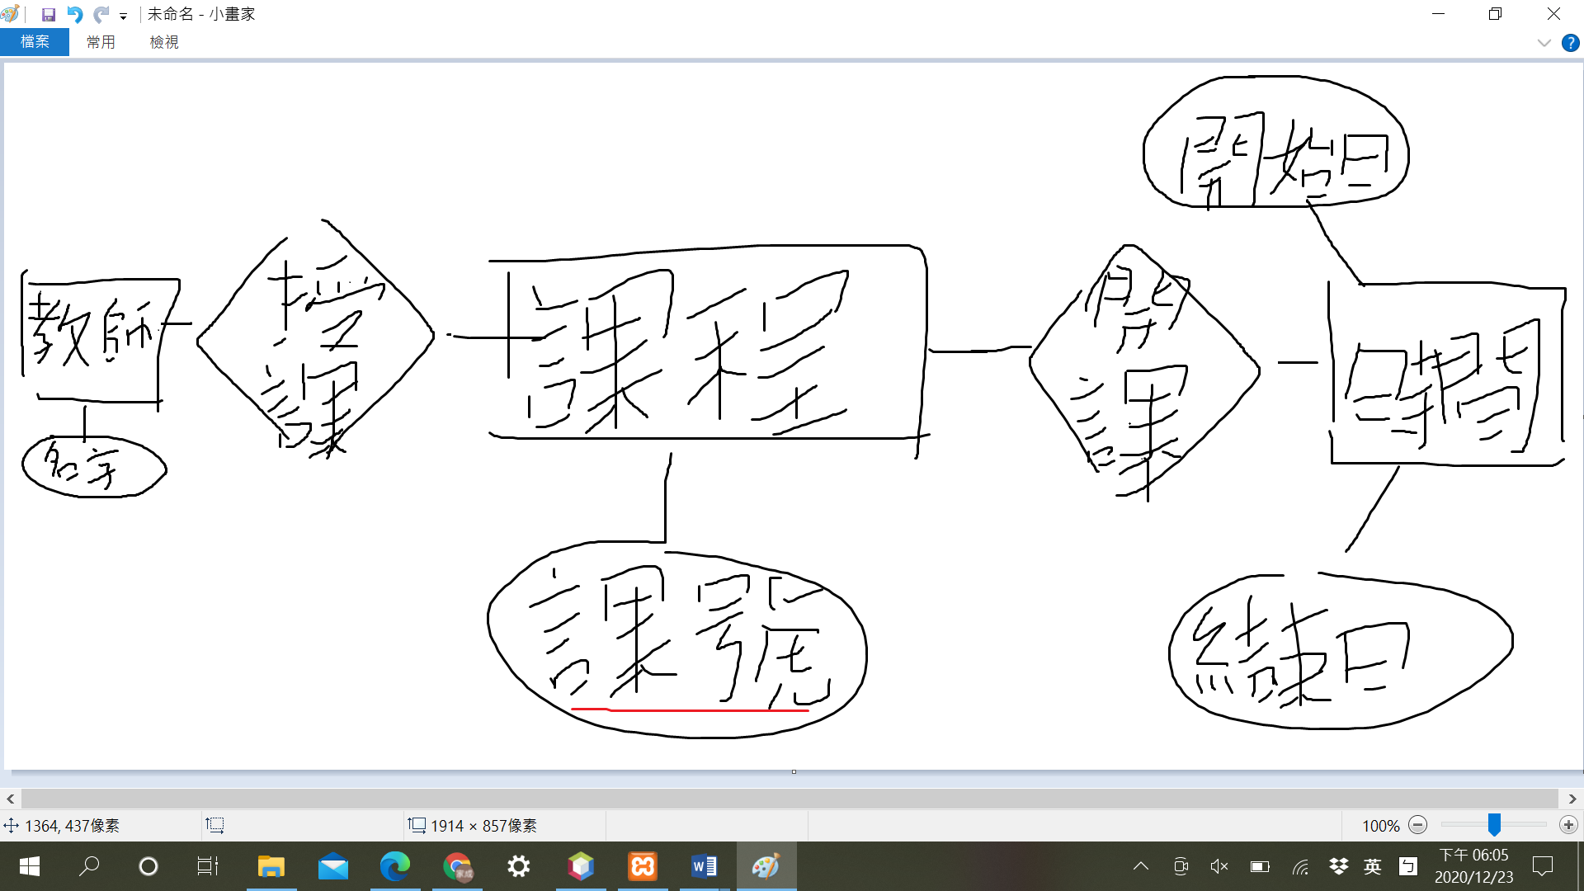

1. (10 points) Insert at least 5 records to each table.

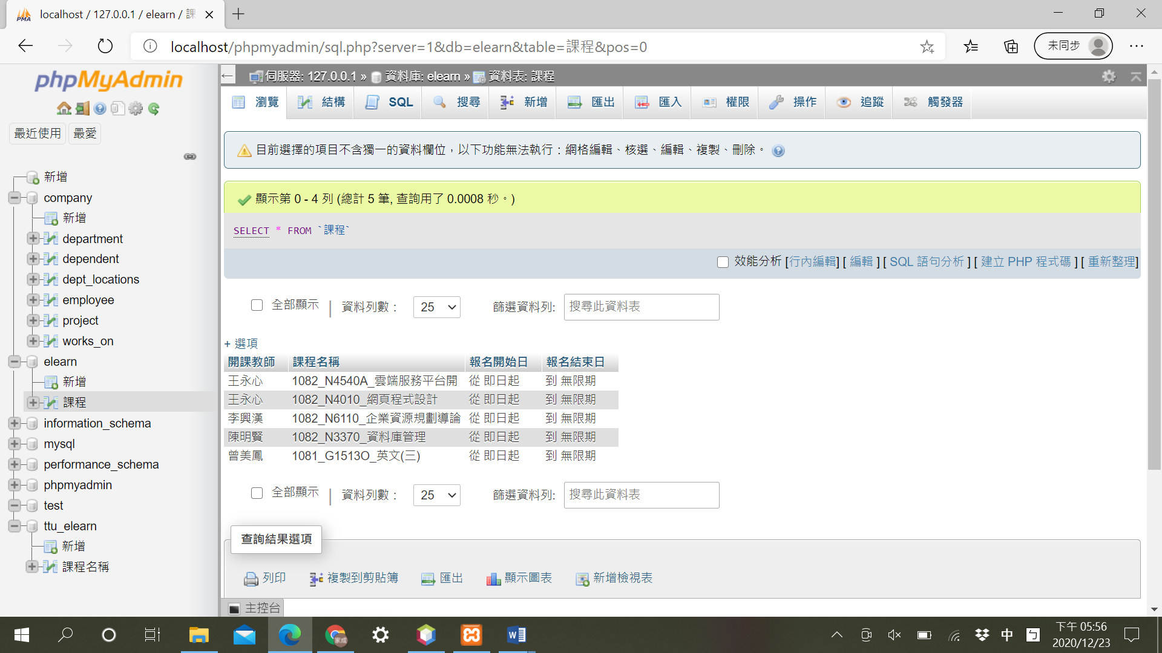

1. (10 points) How to specify key constraint in SQL**?**

**按這個獨一。**

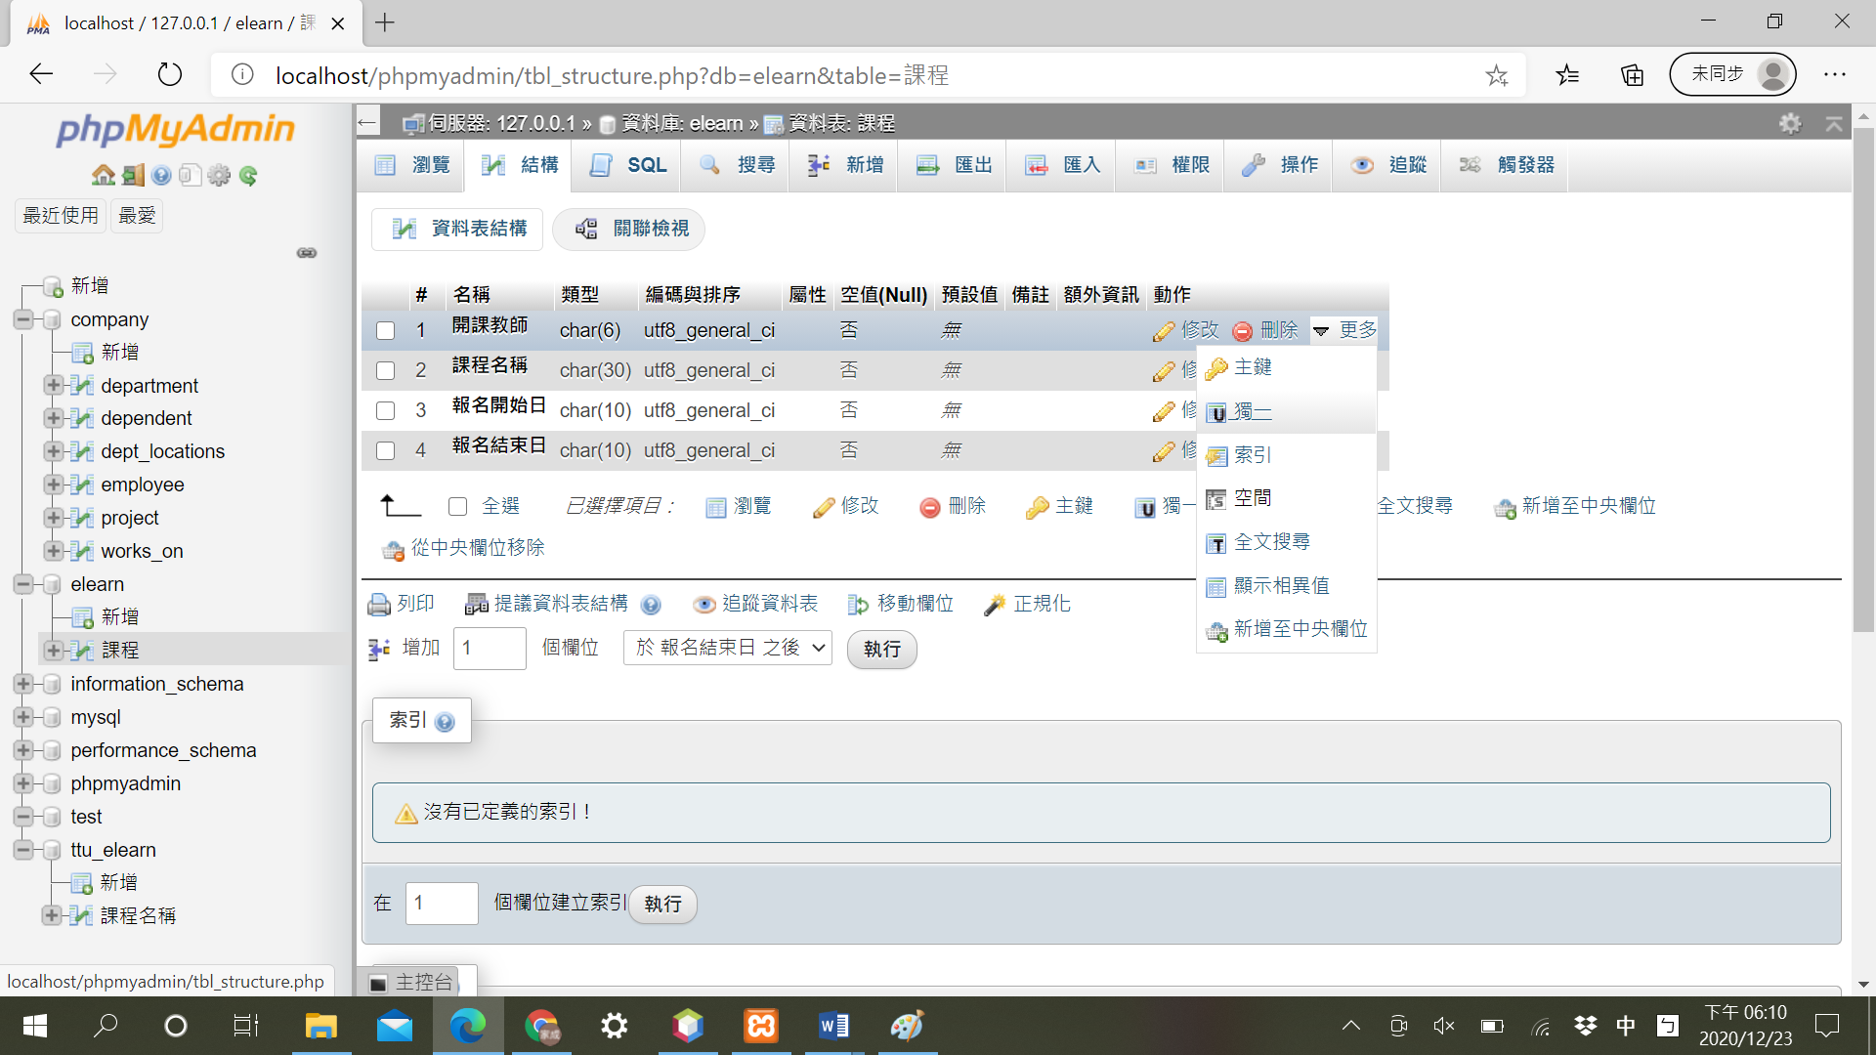

1. (10 points) How to specify Referential Integrity constraint in SQL**?**

**到mysql找到指定的資料庫，然後在上方選單找到設計器，接著在左邊選單找到”建立關聯”，選擇參照鍵及外鍵即可。**

1. (10 points) How to specify key constraint in SQL?

按這個主鍵。

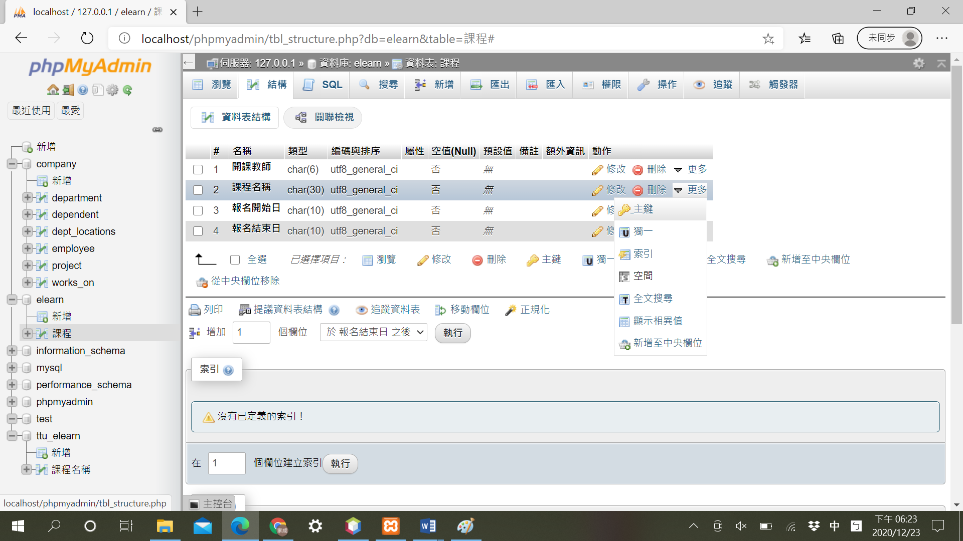

1. (10 points) Textbook exercise 6.2, 6.10
2. (20 points) Write the SQL statements for the following problems:

甲、Retrieve the employee’s first and last name and the first and last name of his or her immediate supervisor.

SELECT Fname,Lname FROM employee;

SELECT Fname,Lname FROM employee WHERE Ssn= Super_ssn;

乙、List all EMPLOYEE Name and his/her department name.

SELECT Fname,Lname,Dname FROM employee,department WHERE employee.Dnumber=department.Dno;

丙、Retrieve all employees in Research department whose salary is between

$30,000 and $40,000.

SELECT * FROM employee WHERE salary>30000 and salary<40000;

丁、Delete all the employee in Research Department.

Delete * FROM employee;